Assignment 2 Write Up
Runjia Tian

Algorithmic Acceleration:

Three various methods for calculating vector-triangle intersection:

Results of Fast Voxelization:

2.3 Results of Non-Watertight Mesh Voxelization
Algorithm: Project Original Boundingbox to a new base plane, and project alone projection vectors from the new base plane grid; calculate intersection points, and inversely calculate nearest voxel centers to the intersection points, and fill vexels with true between intersection points in original voxel grids.
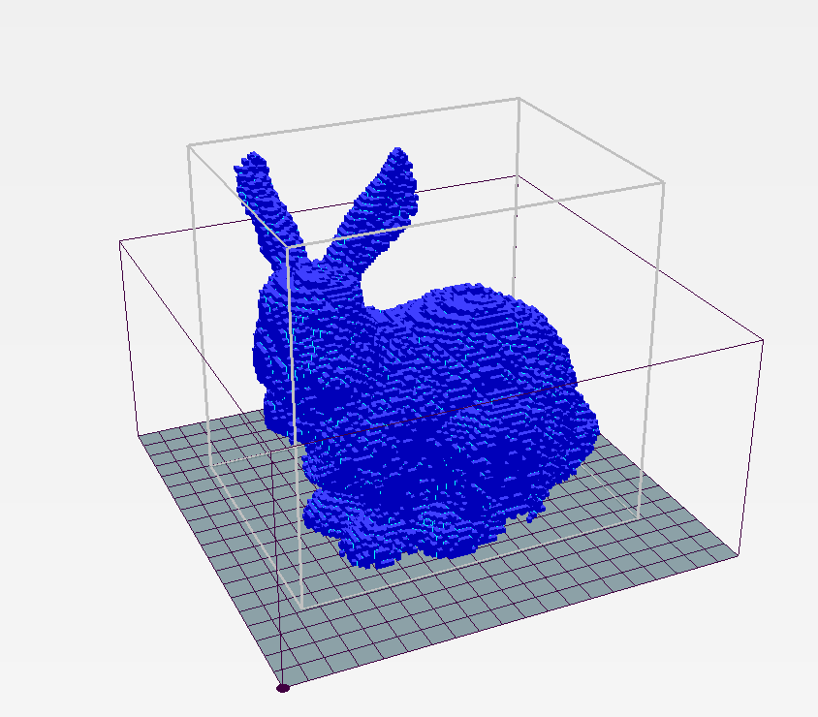
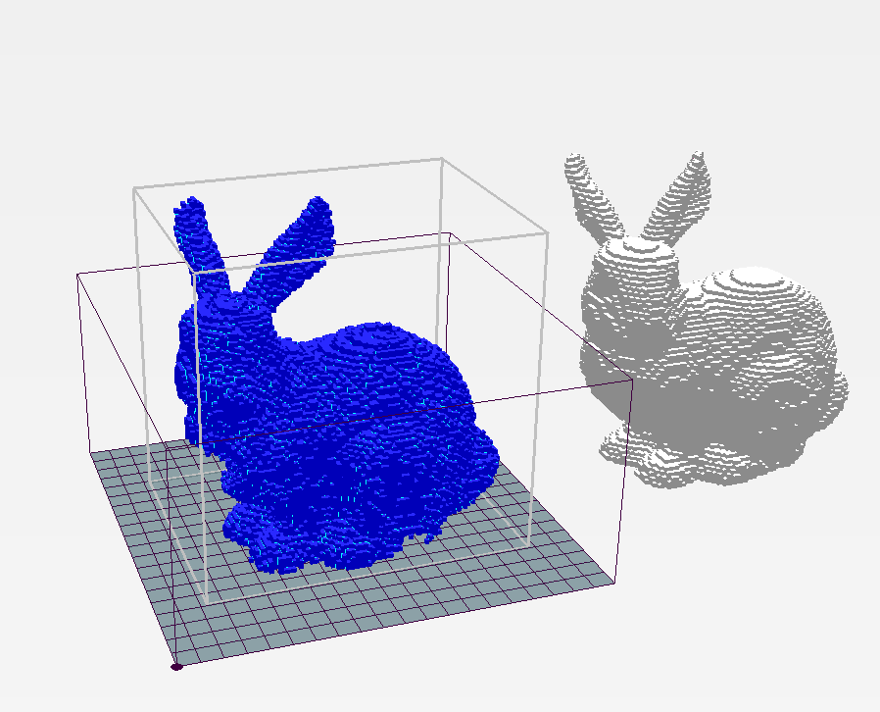

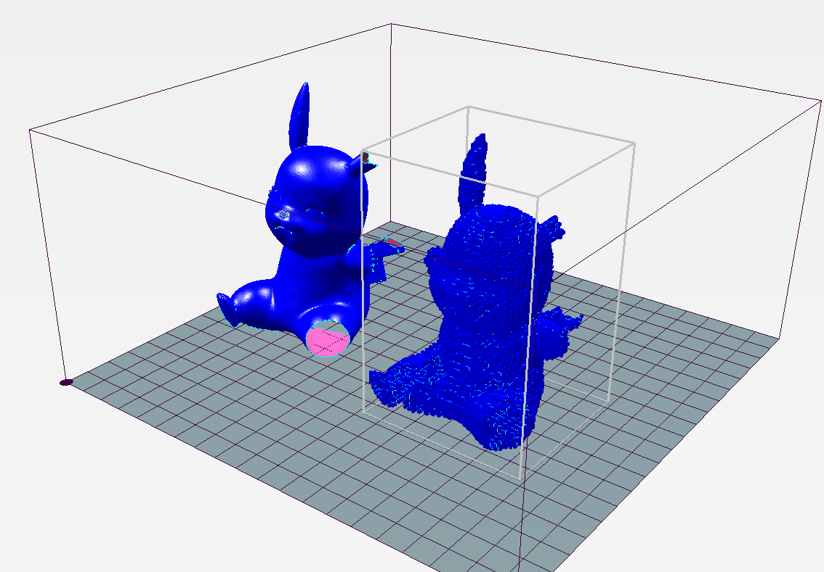
The Pickachu model with holes

Results of Running Marching Cube
fandisk_mc.stl

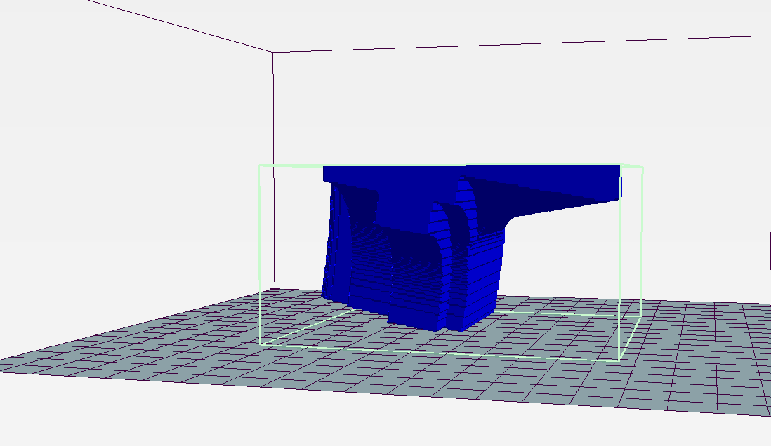
spot_mc.stl
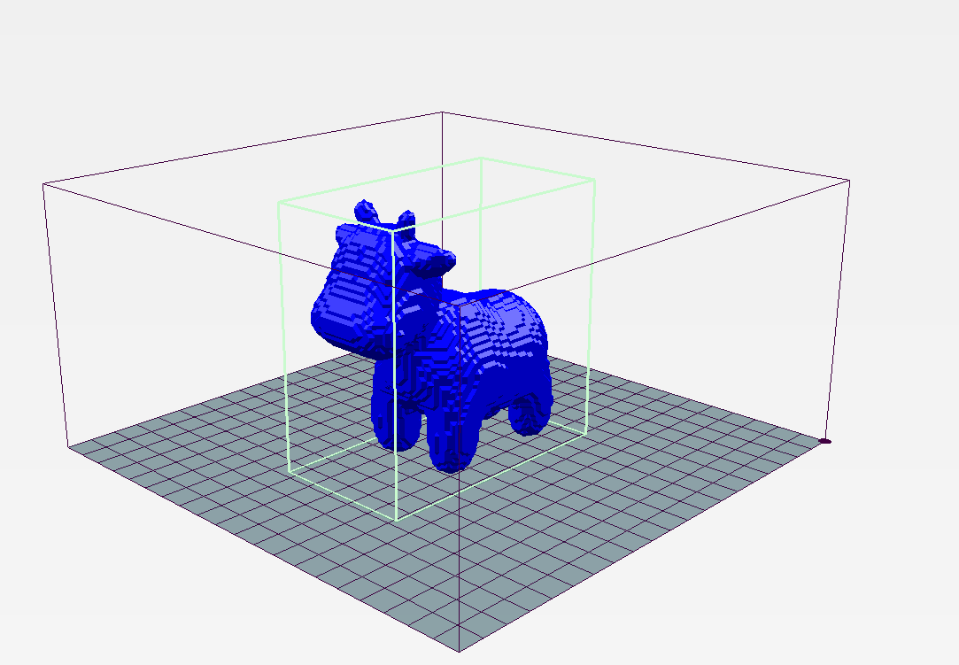
bunny_mc.stl
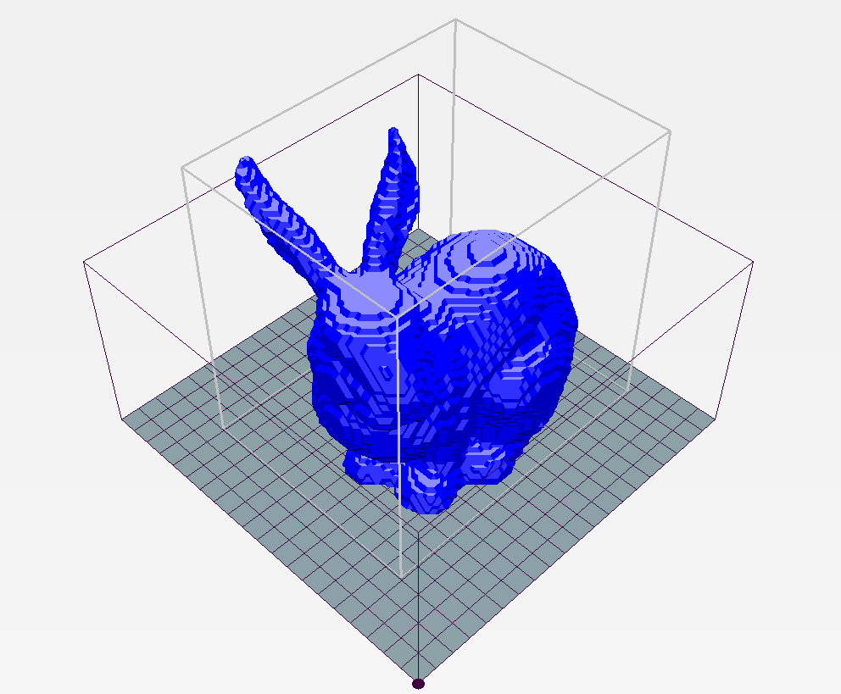
dragon_mc.stl
